**PURBANCHAL UNIVERSITY**

**COLLEGE OF INFORMATION TECHNOLOGY AND ENGINEERING**

**DEPARTMENT OF SCIENCE AND TECHNOLOGY**

**Bachelor in Information Technology**

**(BIT)**

**TINKUNE, KATHMANDU**



**FINAL PROJECT ON**

**STUDENT RECORD SYSTEM**

Submitted to the Department of Science and Technology

**(Course Code: BIT 178 CO)**

**SUPERVISOR**

**Bipin Shrestha**

**SUBMITTED BY:**

**Om Prakash Shrestha (340641)**

**Sagar Malla (340647)**

**BIT 6th Semester (2019)**

**December 2019**

**CERTIFICATE FROM SUPERVISOR**

This is to certify the Project entitled **“STUDENT RECORD SYSTEM”** submitted **by Om Prakash Shrestha, Sagar Malla** to the Department of Science and Technology, College of Information Technology & Engineering towards the partial fulfillment of the requirement for the award of degree of Bachelor in Information Technology (BIT) is an original work carried out by the them under my supervision guidance.

Signature:

Name: Bipin Shrestha

(Project Supervisor)

CITE

Place: CITE, Tinkune, Kathmandu

Date:

**CERTIFICATE FROM EVAULATING TEAM**

This is to certify the Project entitled **“STUDENT RECORD SYSTEM”** submitted by **Om Prakash Shrestha, Sagar Malla,** to the Department of Science and Technology, College of Information Technology & Engineering towards the partial fulfillment of the requirement for the award of degree of Bachelor in Information Technology (BIT) is an original work carried out by them and meets all the requirements defined by the university to award the degree.

Viva-voce examinations of project conduct on:

Signature: Signature:

Name: Kopila Shrestha Name:

(Project Supervisor) (External Examiner)

Signature:

Name: Mr. Bhanu Niroula

(Program Coordinator)

Place: CITE, Tinkune, Kathmandu

Date:

**PROJECT OVERVIEW**

This is our approach to briefly maintain and keep info of the examination record called as “**STUDENT RESULT SYSTEM**". In this project we have included features like creating, viewing, modifying, deleting, and searching of student exam report. This project also has a feature to search. You can search the student progress report by their ID/roll number. The new system requires integrating systems for Examination Information, Grades and Department at one place. It makes data manipulation of projects & employees easy and fast as it is less time consuming and provides efficient searching.

This report includes a development presentation of an information system for managing the record data within a school and college. The system as such as it has been developed is called **STUDENT RECORD SYSTEM**.

**ACKNOWLEDGEMENT**

Every organized report requires a lot of hard work and seeks a lot of helping hands. Up to the completion of this project report, we were not so far from this strategy or rule. First of all, we would like to thank to our subject teacher **Bipin Shrestha** for proper guidance and moderation during the classes.

We owe a thank to our friends for their continuous support and help on the completion of project work. We would like to remember and thank every individual who helped us to complete our project report successfully

**ABSTRACT**

This project represents the record of accounts of a particular Educational institution. It only focuses the faculty basic three types of account only.

**STUDENT RECORD SYSTEM** is a software application for education establishments to record account data. **STUDENT RECORD SYSTEM** provides capabilities for finding student record. Exam Information, secured marks and manage many other account related data need for a student institution. There are custom search capabilities to finding record information. This can make the system easier to navigate and to use maximizing the effectiveness of time and other resource.

**List of abbreviation**

Fig = Figure

SRS = Student Record System

DFD = Data Flow Diagram

Er= Entity Relation

DBMS= Database Management System

SQL= Structured Query Language

SRS= Software Requirement Specification

# **Chapter 1**

# **Introduction**

# **Introduction**

Student record system is a system that record the details of student name, id, Exam marks etc. Student record system display the search result with in a second. A user can enter details of student which they can retrieve the information from the data base. In this age of technology, manual data entry is complex and hard to find accurate information. So as to provide accurate data to the user this system is developed. The main idea is there are number of students in school and college. Every college found difficult to record the data of students. So as a time demand this software fulfill their need for system. Different attractive user interface design is used to design the software which makes easy to interactive between user and system. We use database and database technology are having a major impact on the growing use of computers. The implementation of the system was done using c# and SQL Server 2012 technologies, allowing system to be run in Windows OS.

* 1. **Problem Statement**

Managing result of student is tedious task for every School, College. Many newly open schools have not sufficient resource to maintain result. School will face great problems as number of students, faculty increases. Entering marks by hand and manually may lead dirty report sheet. Once marks enter by handwriting cannot be corrected which loss the printed report card. The storing of result data is a big challenge in such organization. Result stored in the ledger can be difficult to view after long period of time. The storing of result database is permanent nature and can be access anytime in short time.

* 1. **Objective**

The Student record system is developed to fulfill the given objective.

* To store students marks in dbms and to generate of result
  1. **Significant of Student Record System**

Developing this project can help exam section to maintain the records of students. A person with basic knowledge of computer can master in this software due to user friendly User Interface. The main task of this software is to solve immerse problem of record keeping. It maintains records of student in database that is accessible in anytime and can print a marksheet.

* 1. **Features of Project**
* This is very easy to use for each user.
* Quickly print a marksheet of student
* Increase Efficiencies and Reduce Costs
* Transform IT for Higher Education
* Easy Solution
* Easy Admission Process
* Secure All Data
* The user of the database can see all information and also can edit if necessary.

# **Chapter 2**

# **Platform Introduction**

# **Development Platform**

We use C# (.net framework) and MSSQL Server 2012.

C# is an elegant and type-safe object-oriented language that enables developers to build a variety of secure and robust applications that run on the .NET Framework. You can use C# to create Windows client applications, XML Web services, distributed components, client-server applications, database applications, and much, much more. Visual C# provides an advanced code editor, convenient user interface designers, integrated debugger, and many other tools to make it easier to develop applications based on the C# language and the .NET Framework.

The .NET Framework (pronounced dot net) is a software framework developed by [Microsoft](http://en.wikipedia.org/wiki/Microsoft) that runs primarily on [Microsoft Windows](http://en.wikipedia.org/wiki/Microsoft_Windows). It includes a large [class library](http://en.wikipedia.org/wiki/Class_library) known as Framework Class Library (FCL) and provides [language interoperability](http://en.wikipedia.org/wiki/Language_interoperability) (each language can use code written in other languages) across several [programming languages](http://en.wikipedia.org/wiki/Programming_language). Programs written for .NET Framework execute in a software environment (as contrasted to [hardware](http://en.wikipedia.org/wiki/Computer_hardware) environment), known as Common Language Runtime (CLR), an application virtual machine that provides services such as security, memory management, and exception handling. FCL and CLR together constitute .NET Framework.

## C# Features

* C# is a simple, modern, object oriented language derived from C++ and Java.
* It aims to combine the high productivity of Visual Basic and the raw power of C++.
* It is a part of Microsoft Visual Studio7.0.
* Visual studio supports Vb,VC++,C++,Vbscript, Jscript. All of these languages provide access to the Microsoft .NET platform.
* .NET includes a Common Execution engine and a rich class library.
* Microsofts JVM eqiv is Common language run time (CLR).
* CLR accommodates more than one languages such as C#, VB.NET, Jscript, ASP.NET,C ++.
* Source code --->Intermediate Language code (IL) ---> (JIT Compiler) Native code.
* The classes and data types are common to all of the .NET languages.
* We may develop Console application, Windows application, and Web application using C #.
* In C# Microsoft has taken care of C++ problems such as Memory management, pointers etc.
* It supports garbage collection, automatic memory management and a lot.

## Database Platform

A database is an organized collection of [data](http://en.wikipedia.org/wiki/Data_(computing)). The data is typically organized to model aspects of reality in a way that supports [processes](http://en.wikipedia.org/wiki/Process_(computing)) requiring information, such as modeling the availability of rooms in hotels in a way that supports finding a hotel with vacancies.

Database management systems (DBMS) are [computer software](http://en.wikipedia.org/wiki/Computer_software) applications that interact with the user, other applications, and the database itself to capture and analyze data. A general-purpose DBMS is designed to allow the definition, creation, querying, update, and administration of databases. Well-known DBMSs include [MySQL](http://en.wikipedia.org/wiki/MySQL), [PostgreSQL](http://en.wikipedia.org/wiki/PostgreSQL), [Microsoft SQL Server](http://en.wikipedia.org/wiki/Microsoft_SQL_Server), [Oracle](http://en.wikipedia.org/wiki/Oracle_Database), [Sybase](http://en.wikipedia.org/wiki/Sybase) and [IBM DB2](http://en.wikipedia.org/wiki/IBM_DB2).

## SQL Server database Introduction

In [computing](http://en.wikipedia.org/wiki/Computing), Microsoft SQL Server is a [relational database management system](http://en.wikipedia.org/wiki/Relational_database_management_system), currently developed by Microsoft. As a database server, it is a software product with the primary function of storing and retrieving data as requested by other [software applications](http://en.wikipedia.org/wiki/Software_applications) which may run either on the same computer or on another computer across a network (including the Internet).

Microsoft markets at least a dozen different editions of Microsoft SQL Server - aimed at different audiences and for workloads ranging from small single-machine applications to large Internet-facing applications with many [concurrent users](http://en.wikipedia.org/wiki/Concurrent_user).

## SQL Server database system features

* Supports most administrative tasks for SQL Server.
* A single, integrated environment for SQL Server Database Engine management and authoring.
* Dialogs for managing objects in the SQL Server Database Engine, Analysis Services, and Reporting Services, that allows you to execute your actions immediately, send them to a Code Editor, or script them for later execution.
* Non-modal and resizable dialogs allow access to multiple tools while a dialog is open.
* A common scheduling dialog that allows you to perform action of the management dialogs at a later time.
* Exporting and importing SQL Server Management Studio server registration from one Management Studio environment to another.
* Save or print XML Show plan or Deadlock files generated by SQL Server Profiler, review them later, or send them to administrators for analysis.
* A new error and informational message box that presents much more information, allows you to send Microsoft a comment about the messages, allows you to copy messages to the clipboard, and allows you to easily e-mail the messages to your support team.
* An integrated Web browser for quick browsing of MSDN or online help.

# **Chapter 3**

# **System Analysis**

# **Introduction**

Systems analysis is a problem-solving technique that decomposes a system into its component pieces for the purpose of the studying how well those component parts work and interact to accomplish their purpose. As the software system requirements were predictable, it is decided to follow the classical system development life cycle method. This process demands a systematic, sequential approach to software development that begins at the system level and progress through analysis, design, coding, testing and maintenance. The steps that is applicable to all software engineering paradigms. The program is followed by SDLC (Software Development Life Cycle).

### **3.1 Water Fall Model**

Waterfall model divides the lifecycle of the software development process into the phases are shown below:

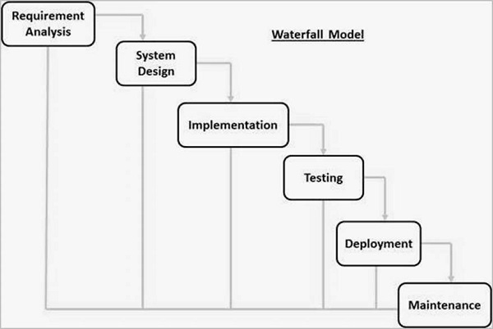

Fig. Water Fall Model

The different phases of this model are feasibility study, requirements analysis and specification, design, coding and unit testing, integration and system testing and maintenance.

The Student record system passes through stages of waterfall model. Requirement of our project is well known, clear and fixed. This project is small and easy to implement in any educational organization for maintaining record. the project is simple and can be master in using software with little knowledge.

### **3.2 Requirement analysis and specification**

The aim of the requirement analysis and specification phase is to understand the exact requirements of the customers and to document them properly. The goal of requirement analysis is to collect and analyze all the related data and information with a view to understanding the customer requirements clearly and weeding out inconsistencies and incompleteness in these requirements. During requirement specifications, the user’s requirements are properly organized and documented in a SRS (software requirement specification) document. The SRS document addresses the functional requirements, the non-functional requirements, and the special requirements on the maintenance and development of the software product, if any.

**3.3 Feasibility Study**

**3.3.1 Technical Feasibility**

The Student record system is desktop based and thus can be install and use in any windows pc. The solution is practical since the objectives of the system development are achievable and realistic. The technology to be used is available, this include use of programming language C# and MySQL database to develop applications.

**3.3.2 Economic Feasibility**

**- Costs and benefits**

1. **Cost Development**

Development cost is very minimal since the tools and technologies used are available online. It’s a group project so there are no personnel costs. Development time is well planned and will not affect other operations and activities of the individuals. Once the system has been developed, the companies purchasing the system will be provide with a manual for training purposes, also physical training will be provided for those individuals that need it. There is no need to purchase new hardware since the existing computers can still be used.

1. **Benefits** 
   1. **Performance Benefits**

Increased speed of report production. Faster creation, access, modification and retrieval of data. Decreased redundancy or duplication of data. Timely access of students’ information and school update. Improved storage of valuable marks of students.

* 1. **Cost-Avoidance Benefits**

Avoid costs of purchasing data backups and storage. Avoid costs of having number of staff of exam section to maintain report of students. Staff Reductions will reduce the cost of salaries since and integrated system will need just a few employees, no need for employees in every departments. It is evident that the system is economically feasible, the benefits outweigh the system costs within the defined period of time acceptable to the user/client. The use of system places the school at a competitive advantage.

**3.4 Preliminary Development Schedule**

The development schedule will be preliminary during the planning phase because it is usually not possible to make accurate estimation without doing some design. The schedule has been estimated has follows

This chapter discusses about the time schedule for the project which is describe in the following Gantt chart

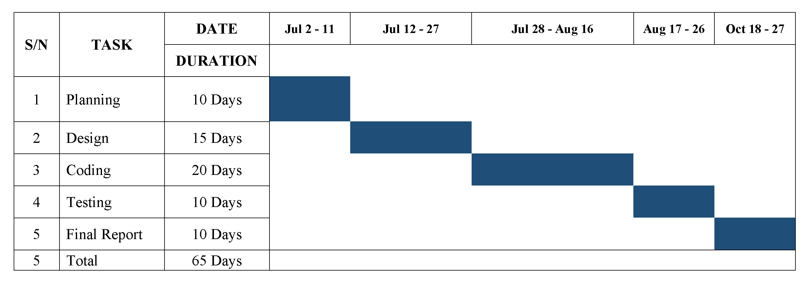

Fig. Gantt chart

# **Chapter 4**

# **System Design**

# **Introduction**

The [design phase](http://searchsoftwarequality.techtarget.com/definition/systems-development-life-cycle) is concerned with the physical construction of the system. Included are the design or configuration of the network (hardware, operating system, programming, etc.), design of user interfaces (forms, reports, etc.), design of system interfaces (for communication with other systems), and security issues. It is important that the proposed design be tested for performance, and to ensure that it meets the requirements outlined during the analysis phase. In other words, the main objective of this phase is to transform the previously defined requirements into a complete and detailed set of specifications which will be used during the next phase. Some of the activities that need to take place during the design phase are:

* Design the application
* Design and integrate the network
* Design and integrate the database
* Create a contingency plan
* Start a Maintenance, Training and Operations plan
* Review the design
* Articulate the business processes and procedures
* Establish a transition strategy
* Deliver the System Design Document
* Review final design

**4.1 S**ystem Architecture Design

A system architecture or systems architecture is the [conceptual model](http://en.wikipedia.org/wiki/Conceptual_model) that defines the [structure](http://en.wikipedia.org/wiki/Structure), [behavior](http://en.wikipedia.org/wiki/Behavior), and more [views](http://en.wikipedia.org/wiki/View_model) of a [system](http://en.wikipedia.org/wiki/System). An architecture description is a formal description and representation of a system, organized in a way that supports reasoning about the [structures](http://en.wikipedia.org/wiki/Structure) and [behaviors](http://en.wikipedia.org/wiki/Behavior) of the system.

System architecture can comprise system [components](http://en.wikipedia.org/wiki/System), the externally visible properties of those components, the relationships (e.g. the behavior) between them. It can provide a plan from which products can be procured, and systems developed, that will work together to implement the overall system. There have been efforts to formalize languages to describe system architecture, collectively these are called [architecture description languages](http://en.wikipedia.org/wiki/Architecture_description_languages).

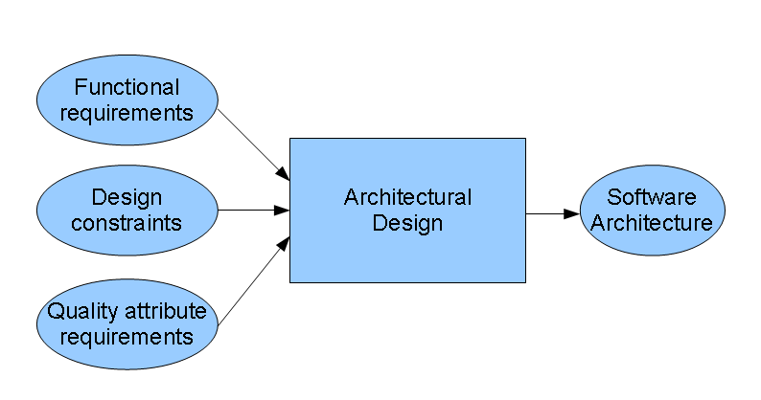

Figure 8: Software Architecture Design

Software architecture refers to the high level structures of a [software system](http://en.wikipedia.org/wiki/Software_system), the discipline of creating such structures, and the documentation of these structures. It is the set of structures needed to reason about the software system. Each structure comprises software elements, relations among them, and properties of both elements and relations. The architecture of a software system is a metaphor, analogous to the [architecture](http://en.wikipedia.org/wiki/Architecture) of a building.

## Data Flow Diagram.

It's easy to understand the flow of data through systems with the right [data flow diagram software](https://www.lucidchart.com/pages/examples/data-flow-diagram). This guide provides everything you need to know about data flow diagrams, including definitions, history, and symbols and notations. You'll learn the different levels of a DFD, the difference between a logical and a physical DFD and tips for making a DFD.

A data flow diagram (DFD) maps out the flow of information for any process or system. It uses defined symbols like rectangles, circles and arrows, plus short text labels, to show data inputs, outputs, storage points and the routes between each destination. Data flowcharts can range from simple, even hand-drawn process overviews, to in-depth, multi-level DFDs that dig progressively deeper into how the data is handled. They can be used to analyze an existing system or model a new one. Like all the best diagrams and charts, a DFD can often visually “say” things that would be hard to explain in words, and they work for both technical and nontechnical audiences, from developer to CEO. That’s why DFDs remain so popular after all these years. While they work well for data flow software and systems, they are less applicable nowadays to visualizing interactive, real-time or database-oriented software or systems.

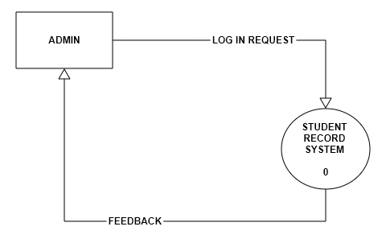

Fig. Zero Level DFD

## 4.3 Use Case Diagram

A use case diagram is a graphic depiction of the interactions among the elements of a system. A use case is a methodology used in system analysis to identify, clarify, and organize system requirements. The relationships between and among the actors and the use cases.

System objectives can include planning overall requirements, validating a [hardware](https://searchnetworking.techtarget.com/definition/hardware) design, testing and [debugging](https://searchsoftwarequality.techtarget.com/definition/debugging) a [software](https://searchmicroservices.techtarget.com/definition/software) product under development, creating an online help reference, or performing a consumer-service-oriented task. For example, use cases in a product sales environment would include item ordering, catalog updating, payment processing, and customer relations.

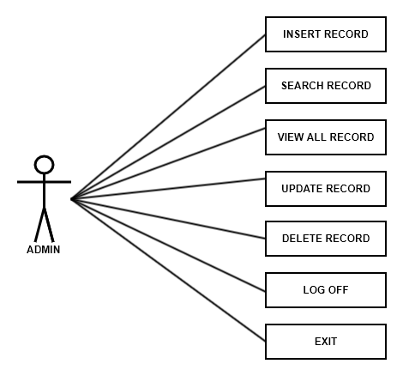

**Fig. Use case diagram**

## Database Design

A database management system (DBMS) is a collection of programs that enables you to [store](http://www.webopedia.com/TERM/S/store.html), modify, and extract information from a [database](http://www.webopedia.com/TERM/D/database.html). There are many different types of database management systems, ranging from small [systems](http://www.webopedia.com/TERM/S/system.html) that [run](http://www.webopedia.com/TERM/R/run.html) on personal computers to huge systems that run on [mainframes](http://www.webopedia.com/TERM/M/mainframe.html). DBMS is a software that handles the storage, retrieval, and updating of data in a computer system.

Ex- SQL Server (Microsoft), MySQL (Freeware), Oracle (Oracle), NoSQL (Oracle), NonStop SQL (Hewlett Packard).

* 1. **ER diagram**

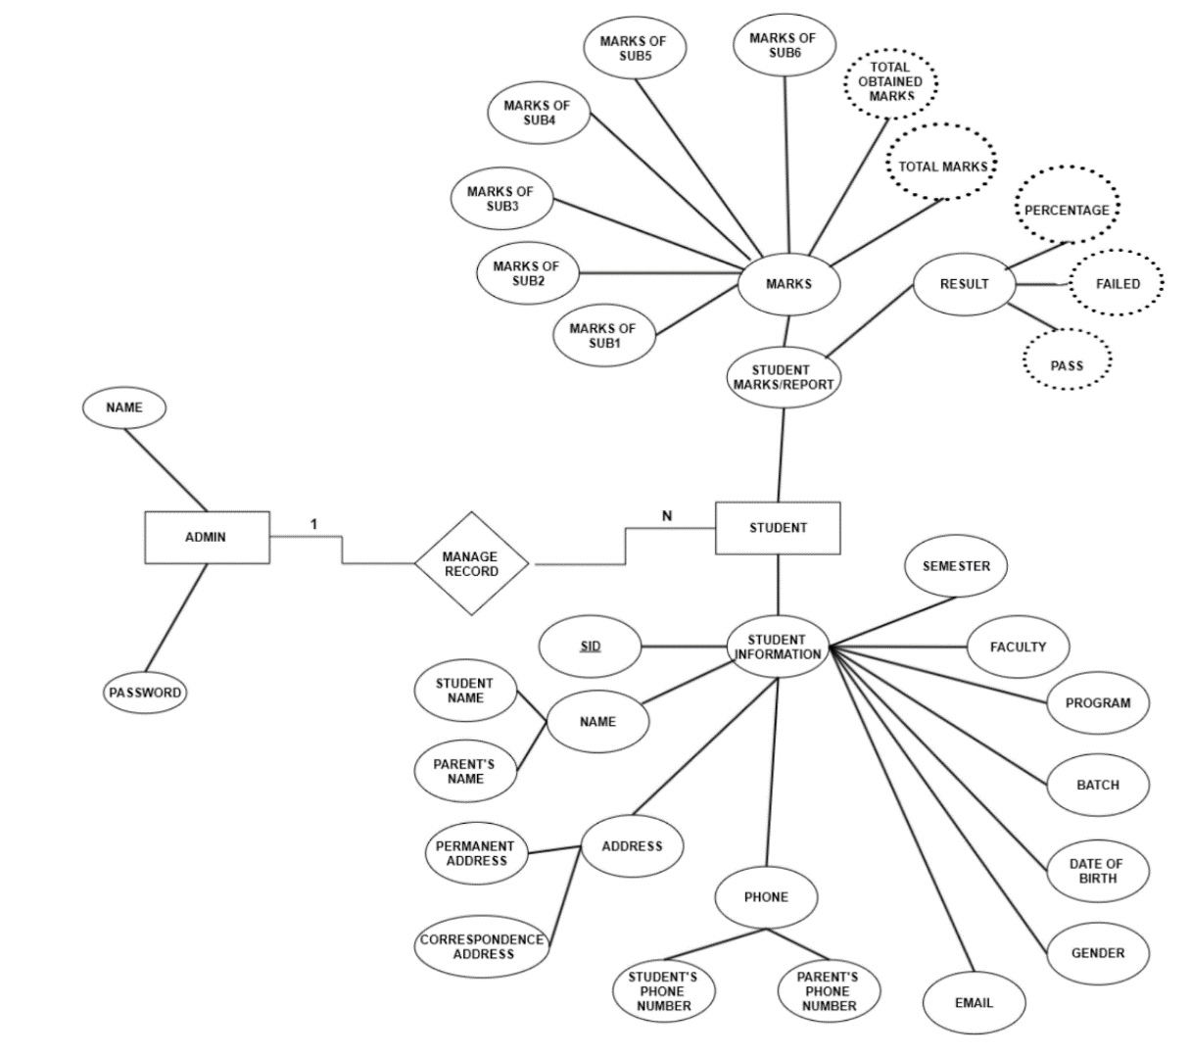

**Fig. ER diagram**

**4.6 Database SQL Query**

CREATE DATABASE Profile;

USE Profile;

CREATE TABLE [dbo].[Marks](

[Sid] [varchar](8) NOT NULL,

[Semester] [char](4) NOT NULL,

[SUB1] [decimal](5, 2) NULL,

[SUB2] [decimal](5, 2) NULL,

[SUB3] [decimal](5, 2) NULL,

[SUB4] [decimal](5, 2) NULL,

[SUB5] [decimal](5, 2) NULL,

[SUB6] [decimal](5, 2) NULL,

[TOTAL_MARKS] [decimal](5, 2) NULL,

[OBTAINED_MARKS] [decimal](5, 2) NULL,

[PERCENTAGE] [decimal](5, 2) NULL,

[RESULT] [char](6) NULL

)

CREATE TABLE [dbo].[Profile](

[Sid] [varchar](8) NOT NULL,

[Name] [varchar](40) NOT NULL,

[P_Name] [varchar](30) NOT NULL,

[P_Con] [bigint] NOT NULL,

[Permanent_Address] [varchar](30) NOT NULL,

[Correspondance_Address] [varchar](30) NOT NULL,

[Phone] [bigint] NOT NULL,

[Email] [varchar](40) NOT NULL,

[Gender] [char](8) NOT NULL,

[DOB] [varchar](50) NOT NULL,

[Batch] [int] NOT NULL,

[Program] [char](10) NOT NULL,

[Faculty] [char](20) NOT NULL,

[Semester] [char](4) NOT NULL,

PRIMARY KEY CLUSTERED

(

[Sid] ASC

)WITH (PAD_INDEX = OFF, STATISTICS_NORECOMPUTE = OFF, IGNORE_DUP_KEY = OFF, ALLOW_ROW_LOCKS = ON, ALLOW_PAGE_LOCKS = ON) ON [PRIMARY]

)

# **Chapter 5**

# **System Development and Implementation**

# **System implementation**

Implementation refers to the final process of moving the solution from development status to production status. Depending on your project, this process is often called deployment, go-live, rollout or installation. For the purposes of Life cycle Step, all of these terms are synonymous with "implementation."

There is no single way to implement an application. It depends on the characteristics of your project and the solution. Some implementations are as easy as saying “we are now live.” This type of implementation can work when the solution is brand new and you are developing and testing in what will become the production environment. In these cases, implementation is just a state of mind. One day the solution is in development, and the next day it is in production.

## 5.1 Front end and back end design

### 5.1.1 Microsoft visual studio

Microsoft Visual Studio is an integrated development environment (IDE) from Microsoft. The database management system (DBMS) is the software that handles all access to the database. Visual Studio and Ms SQL are used in developing our Student Profile System. Visual Studio uses Microsoft software development platforms such as Windows API, Windows Forms, Windows Presentation Foundation, Windows Store and Microsoft Silverlight. It can produce both native code and managed code.

Visual Studio code editor supporting IntelliSense (the code completion component) as well as code refactoring is used to design the Front end. The integrated debugger works both as a source-level debugger and a machine-level debugger.

**5.1.2 Ms SQL Server**

**Ms SQL server is database management system** is the software that handles all access to the database. It is defined as the collection of interrelated data and a set of programs to access those data.

The primary goal of DBMS is to store and retrieve data in both **convenient** (easy method)

and **efficient** (capable of performing well) manner. Some of the examples of DBMS are Oracle, SQL-Server, MySQL, MS Access etc. We have used this system to create, insert, update, retrieve, delete the data store in Database.

# 5.2 Testing

Fig: Level 2 Diagram

Testing is a program consist of providing the program with a set of test inputs (or test cases) and observing if the program behaves as aspect, then the conditions under which a failure occurs are noted for debugging and the correction.

Test is to determine whether it meets the user’s requirement. This is the last chance to detect and correct errors before the system is installed for user acceptant testing. The purpose of the system testing is to consider all the likely variations to which it will be subjected and the push the system to its limits.

Testing is vital to the process of the system. System testing makes a logical assumption that if all the parts of the systems are correct, the goal will be successfully achieved. Inadequate testing leads to error which may not appear until the product is implemented at the real world.

This creates two problems:

* The time lag between the cause and the appearance on the problem (longer the time interval, the more complicated the problem has become), and
* The effect of system errors on the ﬁles and records within the system. Small system error can conceivably explode into a much larger problem.

Effective testing early in the process translates directly into long term cost saving from a reduced number of errors.

A test suit is the set of all test cases with which a given software product is to be tested.

# 5.3 Implementation

In this program we have used visual studio and Ms SQL server tool. Different visual studio tools such as ( Button, Menu, MenuItem, Label, TextBox, ComboBox, RadioButton ) and Ms SQL tools such as(Table, insert, update, delete functions etc) are implemented in this application program. Implementing all the necessary tools of visual studio and Ms SQL server tool, we have created software. Hope you all will like it.

# **Chapter 6**

# **Conclusion and future enhancement**

# Future enhancement

Student record system only deals with exams result. We can integrate with other system like User Management, Student Profile Management, Routine Management, Result Management, Employee Management and Accounts Management etc. We are just a part complete software that can be implement in School. After identifying the and developing the addition system that we can included we can develop entire system.

# 6.1 Limitations

Every report has got its certain limitation and drawbacks. The same is with our project. The few major limitations are:

* It doesn’t include data of their parents and their income.
* Extra curriculum activities are not recorded.
* It is not online based system.

Future enhancement

Student record system only deals with exams result. We can integrate with other system like User Management, Student Profile Management, Routine Management, Result Management, Employee Management and Accounts Management etc. We are just a part complete software that can be implement in School. After identifying the and developing the addition system that we can included we can develop entire system.

# 6.3 Conclusion

Visual Studio and Ms SQL server is used to build this project. So from this approach we have been very much familiar with visual studio tool and Ms SQL server. We have learnt to use different tools such as Button, Menu, MenuItem, Label, TextBox, ComboBox RadioButton, SQL server tools etc. We have done various researches to create one. We have learned various ways to use this program, not only for educational purpose but also for application purpose.

We have been through a lot research and understanding between our team members. Moreover, we are now familiar with almost all the features of visual studio and Ms SQL tool.

Our project is a short approach which can be used for commercial purpose after more advancement.

# 7. Bibliography

* https://www.visualstudio.com/
* <https://code.visualstudio.com/>
* <https://www.smashingmagazine.com/2018/01/visual-studio-code/>
* <https://en.wikipedia.org/wiki/Microsoft_Visual_Studio>/
* <https://www.gliffy.com/>
* Cbtsam.com/csharp-tutorials